University of Regina

ENSE 400/477



**Project Night Terror System & Object Design**



*Author: Advisor:*

Evan Geissler Dr. Christine Chan

200331033



Last Modified

February 24, 2019

**Revision History**

**Revision Version Date**

Version 1 February 24, 2019

**Table of Contents**

**1 Introduction………………………………………………………………………………….…......**

1.1 Purpose.............................………………………………..………………..........………....

**2 Class Diagrams..........………….………………...…………….....……………………………**

2.1 Characters………………………………………………….......................

2.2 Collectables………………………………………………….......................

2.3 Weapons………………………………………………….......................

**3 Flow Chart Structures......……….………………...…………….....……………………………**

3.1 Purpose**.………………...…………….....………………........……**

3.2 General Game Flow**.………………...…………….....………………........……**

3.3 Saving & Loading**.………………...…………….....………………........……**

**4 Perk Trees..........……….…………...…………….....……………………………**

4.1 Purpose………………………………………………….......................

4.2 Health………………………………………………….......................

4.3 Flashlight………………………………………………….......................

4.4 Pistol………………………………………………….......................

4.5 Rifle………………………………………………….......................

4.6 Cross………………………………………………….......................

4.7 Knife………………………………………………….......................

**5 Blend Spaces..........……….…………...…………….....……………………………**

5.1 Purpose………………………………………………….......................

5.2 General Blend Space………………………………………………….......................

**6 State Machines..........……….…………...…………….....……………………………**

6.1 Purpose………………………………………………….......................

6.2 Main Character………………………………………………….......................

6.3 Heavy Demon………………………………………………….......................

6.4 Light Demon………………………………………………….......................

6.5 Main Demon………………………………………………….......................

6.6 Ghost………………………………………………….......................

6.7 Main Ghost………………………………………………….......................

**7 AI Behaviour Trees..........……….…………...…………….....……………………………**

7.1 Purpose………………………………………………….......................

7.2 Main Character………………………………………………….......................

7.3 Heavy Demon………………………………………………….......................

7.4 Light Demon………………………………………………….......................

7.5 Main Demon………………………………………………….......................

7.6 Ghost………………………………………………….......................

7.7 Main Ghost………………………………………………….......................

**List of Figures**

Figure 2-1. Character Class Diagram………………………………………………….......................

Figure 2-2. Collectable Class Diagram…………………………………………………....................

Figure 2-3. Weapon Class Diagram………………………………………………............................

Figure 3.1-1. Basic Flowchart of the Game……………………………………….............................

Figure 4.1-1. Perk Tree Example …………………….........……………………………………..........

**List of Tables**

Table 2.1-1. ……………….....…………………………………………………......

Table 2.1-2. …......…………………………………………......

Table 2.1-3. …………………………..............................................……………......

**1 Introduction**

* 1. **Purpose**

The purpose of this document is to outline and summarize the class diagrams and structures of Project Night Terror. It is important to note that as a game, there are very many structures involved. In response, this document will outline major classes, structures, and objects. It is also important to note that an Unreal Engine 4 Blueprint is a type of representation for classes and classes will be created through blueprints instead of text code.

1. **Class Diagrams**

**2.1 Characters**

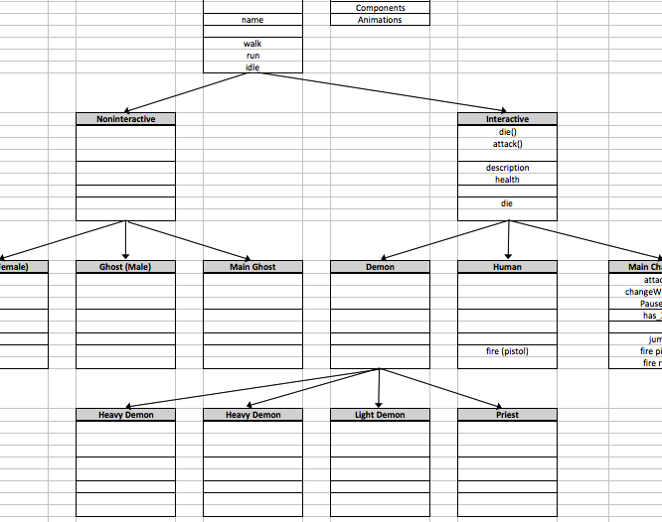

***Figure 2-1. Character Class Diagram***

**2.2 Collectables**

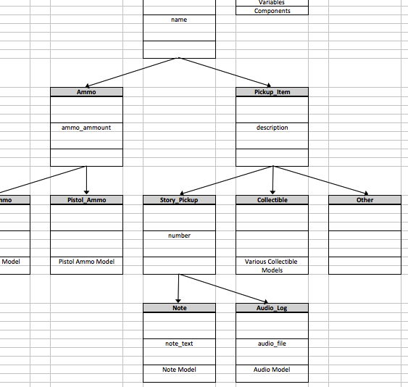

***Figure 2-2. Collectable Class Diagram***

**2.3 Weapons**

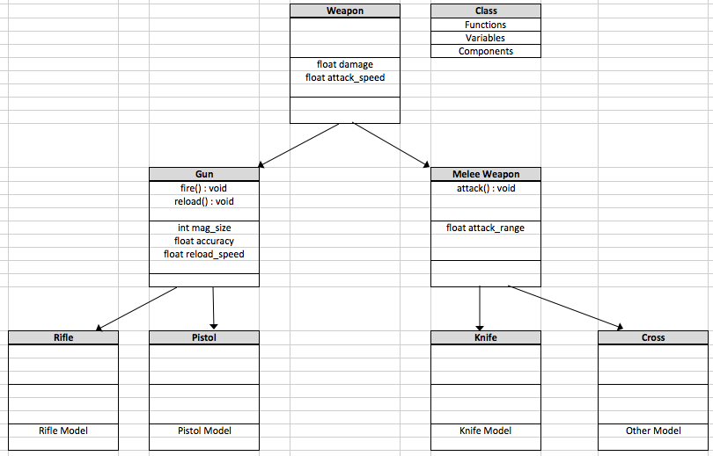

***Figure 2-3. Weapon Class Diagram***

**3 Flow Chart Structures**

**3.1 Purpose**

**3.2 General Game Flow**

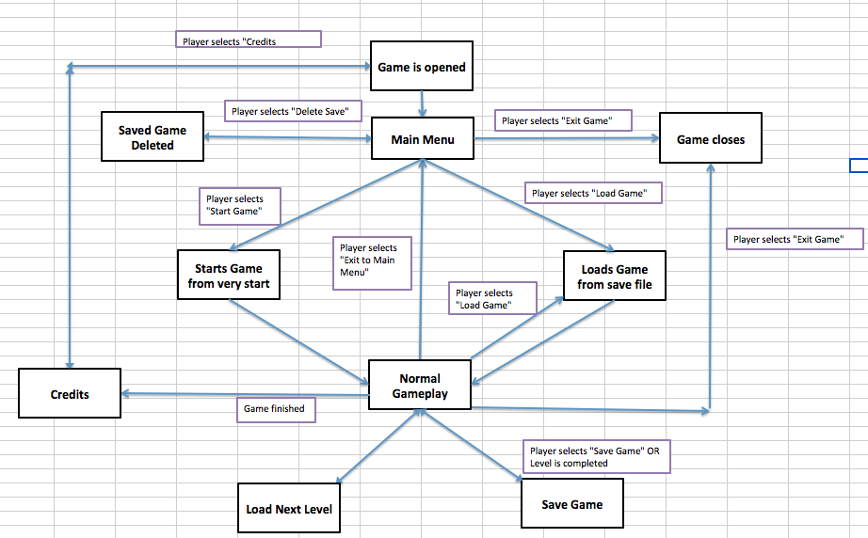

***Figure 3.1-1. Basic Flowchart of the Game***

**3.3 Saving & Loading**

**4 Perk Trees**

**4.1 Purpose**

Throughout the game players collect upgrades to enhance their character in different categories. The different areas are: health, flashlight, pistol, rifle, cross, and knife. The player can select any perk the wish as long as all attached previous nodes have been chosen already. Initial nodes in the tree can be chosen with no prerequisite nodes required.

For example, in the figure below node 1 and node 2 can be chosen right away. However, node 3 can only be chosen once node 1 has been previously chosen. Node 4 can only be chosen once node 1 and node 2 have been previously chosen.

***Figure 4.1-1. Perk Tree Example***

**4.2 Health**

**4.3 Flashlight**

**4.4 Pistol**

**4.5 Rifle**

**4.6 Cross**

**4.7 Knife**

**5 Blend Spaces**

**5.1 Purpose**

A blend space is used to create

**5.2 General Blend Space**

**6 State Machines**

**6.1 Purpose**

The state machines described below allow the characters to move from one animation state to another. The state machines allow for smoother transitions created by blend spaces and also allow separation of unique animations such as dying or a normal movement blend space versus a movement with a weapon blend space.

**6.2 Main Character**

**6.3 Heavy Demon**

**6.4 Light Demon**

**6.5 Main Demon**

**6.6 Ghost**

**6.7 Main Ghost**

**7 AI Behaviour Trees**

**7.1 Purpose**

The behaviour trees help the AI to determine what it should be doing. In the figures below

**7.2 Main Character**

**7.3 Heavy Demon**

**7.4 Light Demon**

**7.5 Main Demon**

**7.6 Ghost**

**7.7 Main Ghost**